

Process Design Document (PDD)

Vitality Vision

© 2005–2019 UiPath. All rights reserved.
NOTE:
This version of the document and its current content is meant to serve as an example for business users (e.g. process SME) and it is intended to help with the creation of the process design documentation for RPA.
The current example`s content is fictive or adjusted to remove real confidential data and it should not be replicated to the automation of other business processes. All the process steps and screenshots in the PDD should be captured entirely from scratch and included here for the automation of the process is scope.
The list of examples is not exhaustive. Additional entries may be added or removed, case by case, as required to provide relevant data for RPA.

Document History
Date | Version | Role | Name | Organization (Dept.) | Function | Comments
07.02.2026 | 1.0 | Author | Tan Hng Wu | IT Department | Business Analyst | Created document v 1.0

Document Approval Flow
Version | Flow | Role | Name | Organization (Dept.) | Signature and Date:
1.0 | Document prepared by | Business Analyst | Tan Hng Wu | NIL

Table of Contents

I. Introduction
I.1 Purpose of the Document
I.2 Objectives
I.3 Key Contacts
I.4 Minimum Prerequisites for Automation

II. As-Is Process Description
II.1 Process Overview
II.2 Applications Used in the Process
II.3 As-Is Process Map
II.4 Detailed As-Is Process Steps
II.5 Input Data Description

III. To-Be Process Description
III.1 To-Be Detailed Process Map
III.2 Parallel Initiatives / Overlap (if applicable)
III.3 In Scope for RPA
III.4 Out of Scope for RPA
III.5 Business Exceptions Handling

Introduction

I.1 Purpose of the Document

The purpose of this automation is to streamline the marketing and data entry operations for Vitality Vision. Currently, the extraction of specialist data, validation of client medical records, and dissemination of promotional materials are performed manually. This manual approach is time-intensive, prone to human error, and insufficient for handling the projected increase in client volume.

I.2 Objectives

The objective of this project is to deploy a UiPath Attended Bot to:
- Eliminate Manual Data Entry: Automate the transfer of patient records from the Medical Portal to the Basic Medical Screening Data Bank.
- Ensure Data Integrity: Apply strict validation rules (Age, Height, Email format) before data submission to prevent "garbage-in" data.
- Enhance Scalability: Manage the anticipated peak period volume (90-100 records/day) and the projected 10% year-over-year growth without hiring additional staff.
- Improve Engagement: Automate the "Featured Specialist" updates to the publicity team and send targeted promotional emails to clients based on health metrics (BMI/BP) and attending clinics.
- Optimize Resource Allocation: Free up the 3 Full Time Employees (FTEs) from repetitive tasks (currently taking 7 minutes per record) to focus on higher-value client interactions.

I.3 Key Contacts

The specifications document includes concise and complete requirements of the business process and it is built based on the inputs provided by the process Subject Matter Expert (SME)/ Process Owner.
The Process Owner is expected to review it and provide signoff for accuracy and completion of the steps, context, impact and complete set of process exceptions. The names have to be included in the table below.
Role | Name | Contact details  (email, phone number) | Notes
Business Analyst | Tan Hng Wu | hngwudev@gmail.com | Point of contact for questions related to process details & exceptions

I.4 Minimum Prerequisites for Automation

- Filled in Process Design Document
- Test Data to support development
- User access and user accounts creations (licenses, permissions, restrictions to create accounts for robots)
- Credentials (user ID and password) required to logon to machines and applications
- Dependencies with other projects on the same environment

As-Is Process Description

II.1 Process Overview

General information about the process selected for RPA prior to automation.
# | Item | Description
1 | Process full name | Vitality Vision Marketing Outreach & Data Management
2 | Process Area | Marketing & Operations
3 | Department | Marketing Team
4 | Process short description  (operation, activity, outcome) | The team extracts daily featured specialist data to email the publicity division. They then retrieve patient records from a portal, manually validate fields, enter valid data into a web form, and send targeted promotional emails based on health metrics.
5 | Role(s) required for performing the process | Marketing Staff
6 | Process schedule and frequency | Daily, Monday to Friday, starting at 9:00 AM
7 | # of items processes /reference period | ~90-100 records per day (Peak Season)
8 | Average handling time per item | 3 minutes per record
9 | Peak period (s) | End of the year
10 | Transaction Volume During Peak period | 90 - 100 records per day
11 | Total # of FTEs supporting this activity | 3 Full Time Employees
12 | Expected increase of volume in the next reference period | Volumes are expected to increase by 10% in the following year
13 | Level of exception rate | High (due to manual validation errors and data entry mistakes)
14 | Input data | Vitality Vision Website (Specialist & Customer Data), Medical Records Portal (Patient Data), Business Rules (BMI/BP logic), assets and credentials
15 | Output data | Excel Files (Specialists & Customers), Google Form Entries (Patient Data), Outlook Emails (Publicity updates & Customer promotions)
*Add more rows to the table to include relevant data for the automation process. No fields should be left empty. Use “n/a” for the items that don`t apply to the selected business process.

II.2. Applications Used in the Process

The table includes a comprehensive list all the applications that are used as part of the process automated, at various steps in the flow.
# | Application name & version | System  Language | Thin/Thick  Client | Environment/  Access method | Comments
1 | Outlook | EN | Thick Client | Windows Application | For Sending Emails
2 | UI Path Studio | EN | Thick Client | Windows Application | For running the bot
3 | Excel | EN | Thick Client | Windows Application | For master data
4 | Vitality Vision Website | EN | Thick Client | Website | For extracting Data
5 | Google forms Website | EN | Thick Client | Website | For Inserting Medical Records
*Add more rows to the table to include the complete list of applications.

II.3 As-Is Process Map

High Level As-Is Process Map:
This chapter depicts the As Is business process at a High Level to enable developers to have a high-level understanding of the current process.
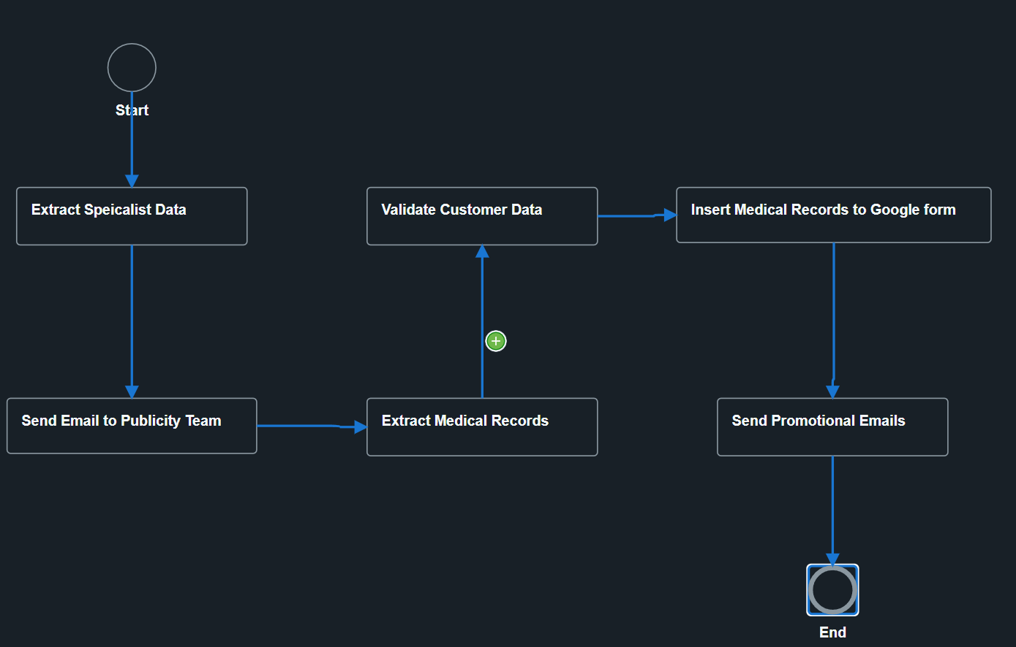

Detailed As-Is Process Map:
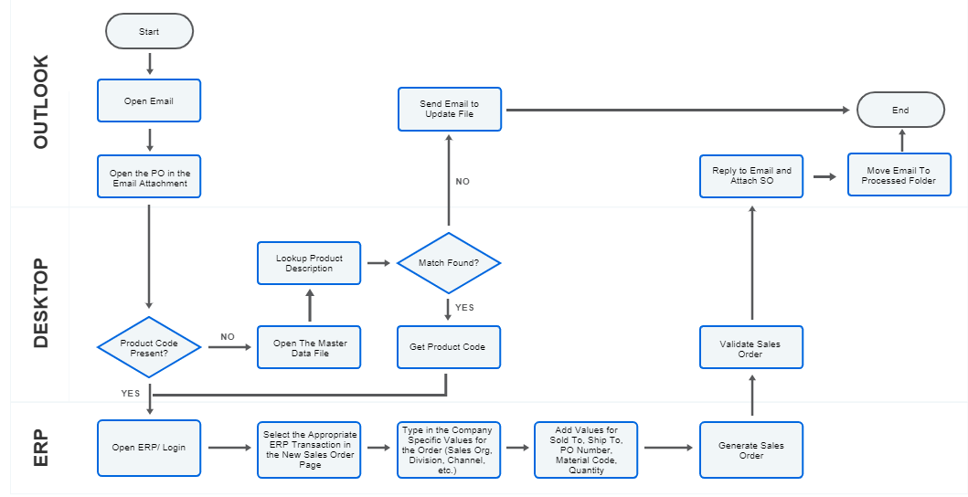
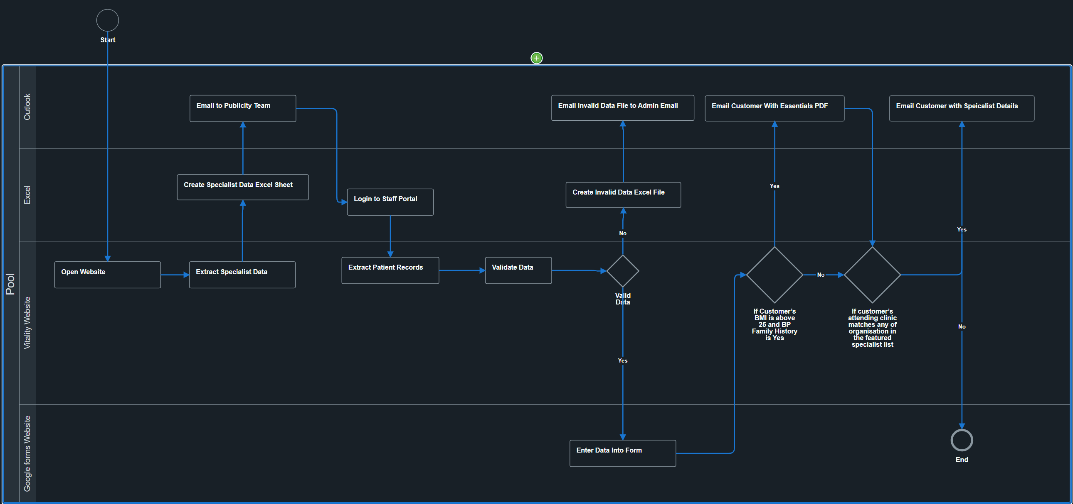

II.4 Detailed As-Is Process Steps

This chapter depicts the As-Is business process in detail to enable the Developer to build the automated process.
 | Detailed As-Is Process Steps
Step | Input | Description | Details (Screen/ Document/ Video recording Index) | Exception Handling | Possible Actions | Business Rules Library Index
See doc attached

To-Be Process Description

This chapter highlights the expected design of the business process after automation.

III.1 To-Be Detailed Process Map

Highlight Bot interventions/ to-be automated steps with different legend/ icon (orange)

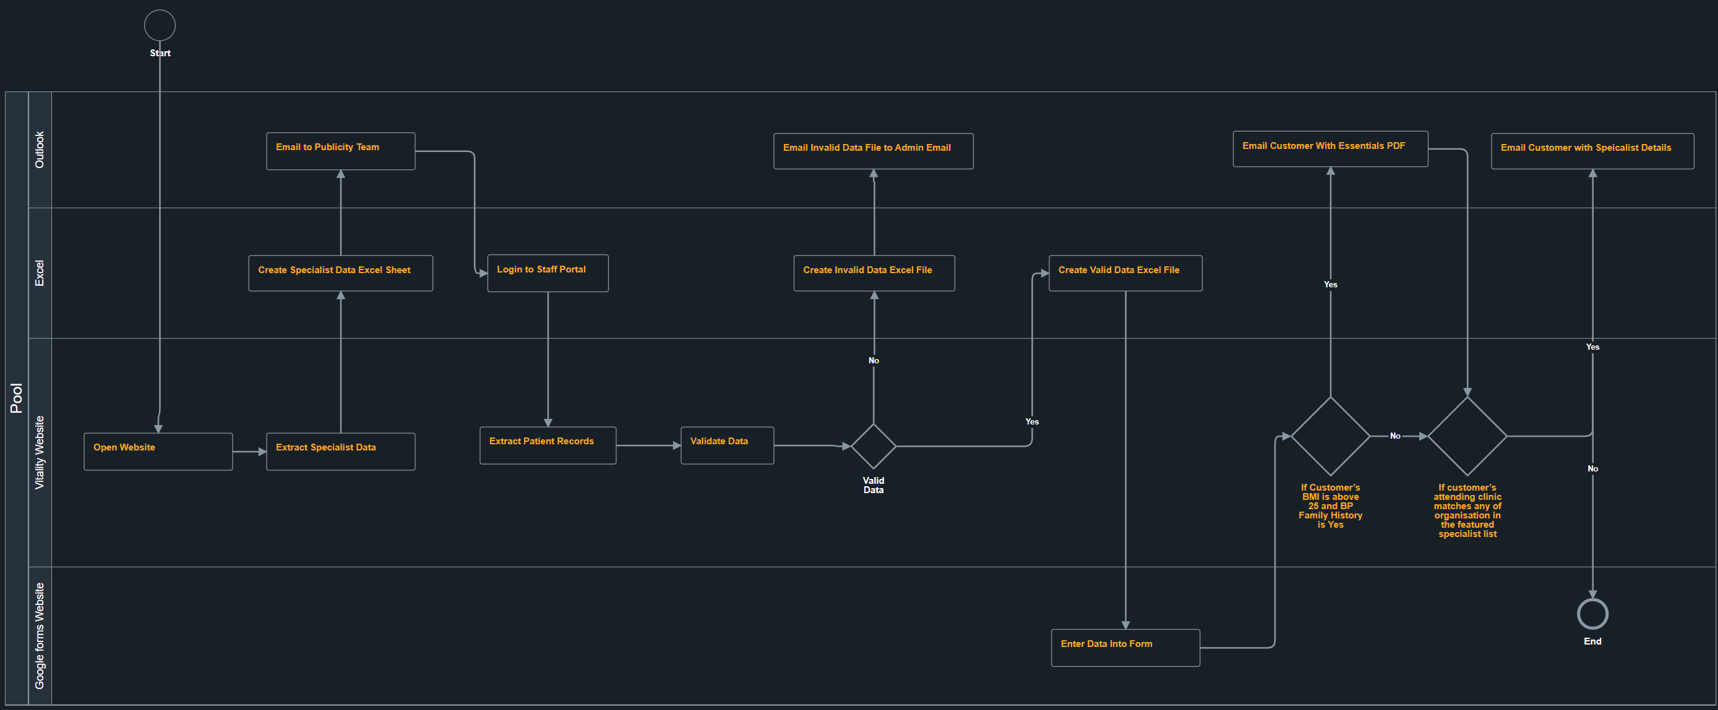
- Added creation of valid Customer Excel File
*Mention below if process improvements were performed on the To-Be design and detail them

III.5 Business Exceptions Handling

The Business Process Owner and Business Analysts are expected to document below all the business exceptions identified in the automation process. These can be classified as:
Known | Unknown
Previously encountered. A scenario is defined with clear actions and workarounds for each case. | New situation never encountered before. It can be caused by external factors. Cannot be predicted with precision, however if it occurs, it must be communicated to an authorized person for evaluation.

Known Exceptions
The table below reflects all the business process exceptions captured during the process evaluation and documentation. These are known exceptions, met in practice before. For each of these exceptions, define a corresponding expected action that the robot should complete if it encounters the exception.
BE # | Exception name | Step | Parameters | Action to be taken
1 | Name is empty or contains non-alphabetic characters | Validate Data | Name | Log in Invalid Customer Data (dd-MM-yyyy).xlsx and proceed to the next row.
2 | Age is non-numeric or out of range (1-100) | Validate Data | Age | Log in Invalid Customer Data (dd-MM-yyyy).xlsx and proceed to the next row.
3 | Gender is not 'Male' or 'Female' | Validate Data | Gender | Log in Invalid Customer Data (dd-MM-yyyy).xlsx and proceed to the next row.
4 | Height is non-numeric or out of range (0.5m - 2.5m) | Validate Data | Height (m) | Log in Invalid Customer Data (dd-MM-yyyy).xlsx and proceed to the next row.
5 | Weight is non-numeric or out of range (30kg - 300kg) | Validate Data | Weight (Kg) | Log in Invalid Customer Data (dd-MM-yyyy).xlsx and proceed to the next row.
6 | Email format is invalid | Validate Data | Email Address | Log in Invalid Customer Data (dd-MM-yyyy).xlsx and proceed to the next row.
7 | Smoke status is not 'Yes' or 'No' | Validate Data | Smoke | Log in Invalid Customer Data (dd-MM-yyyy).xlsx and proceed to the next row.
8 | Drink status is not 'Yes' or 'No' | Validate Data | Drink | Log in Invalid Customer Data (dd-MM-yyyy).xlsx and proceed to the next row.
9 | BP Family History is not 'Yes', 'No', or 'Unsure' | Validate Data | BP Family History | Log in Invalid Customer Data (dd-MM-yyyy).xlsx and proceed to the next row.
10 | On Medication status is not 'Yes' or 'No' | Validate Data | On Medication | Log in Invalid Customer Data (dd-MM-yyyy).xlsx and proceed to the next row.
11 | Medication details missing or invalid based on status | Validate Data | Medication, On Medication | Log in Invalid Customer Data (dd-MM-yyyy).xlsx and proceed to the next row.
12 | Clinic Name is empty or contains invalid characters | Validate Data | Attending Clinic | Log in Invalid Customer Data (dd-MM-yyyy).xlsx and proceed to the next row.
13 | Clinic Email is invalid or missing | Validate Data | Clinic Email Address, Attending Clinic | Log in Invalid Customer Data (dd-MM-yyyy).xlsx and proceed to the next row.

Unknown Exceptions
For all the other unanticipated or unknown business (process) exceptions, the robot should:
Send an email notification at exceptions@acme-test.com with an excel file with the errors.
BE # | Exception Type | Step | Action to be taken
1 | File Access Error | System.IO.IOException detected (e.g., Excel file is open). | Abort Immediately. Display Message Box alerting user to close the file.
2 | General System Error | Any other unknown exception (e.g., Selector not found, Browser timeout). | Retry the activity (Max 3 times).
3 | Persistent Error | General error persists after 3 retries. | Abort execution.

